**VAISHALI BOKADIYA**

**AZURE DATABRICKS DAY 6 ASSESSMENT ON**

**UTILITY CATALOG**

**NOTES:**

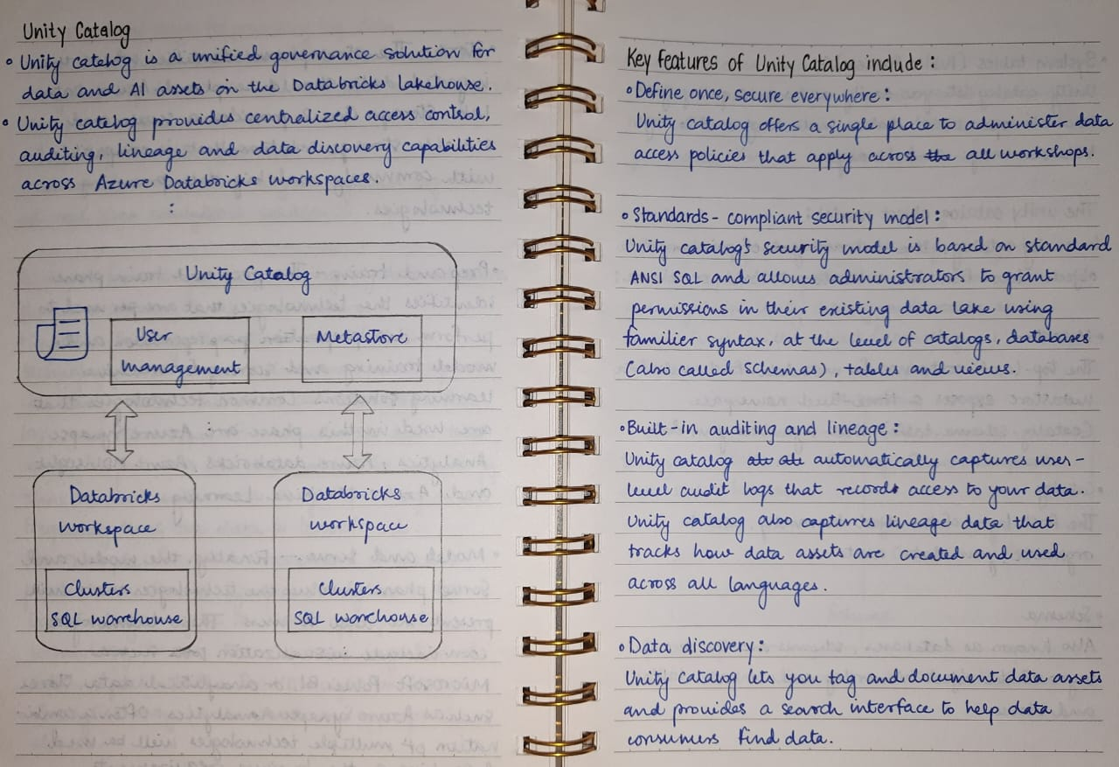

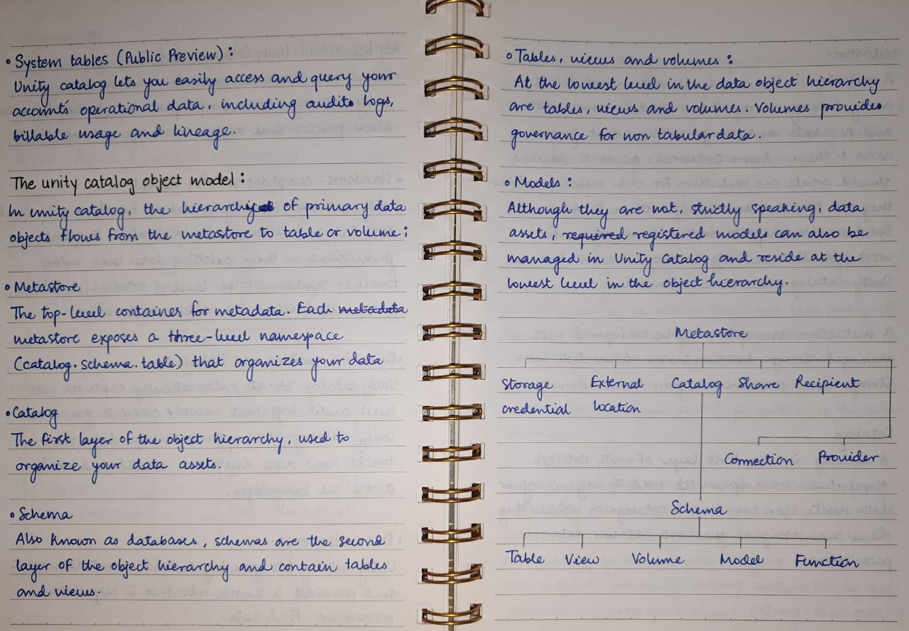

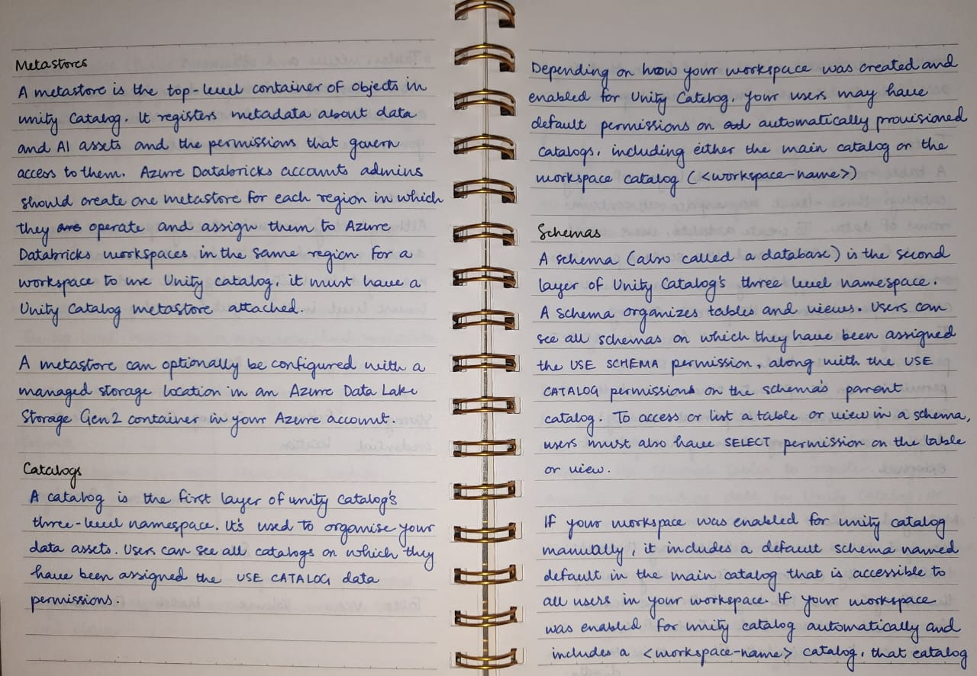

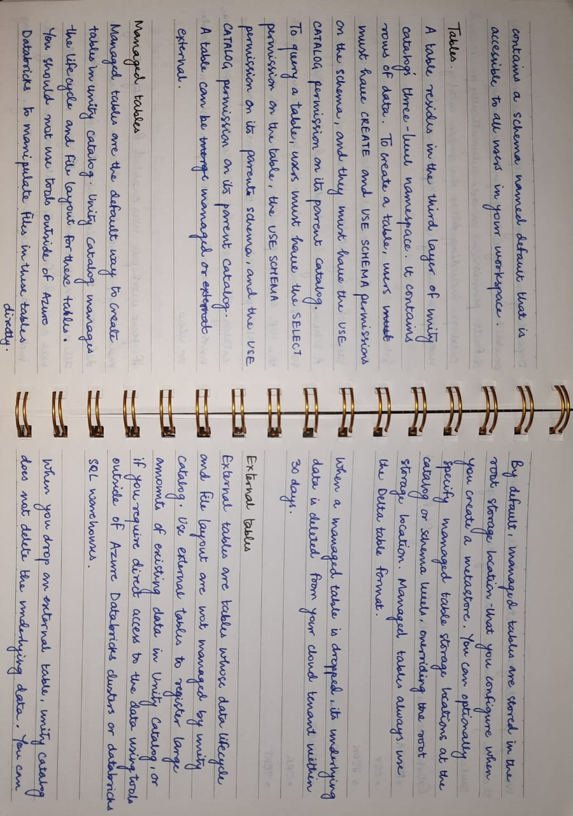

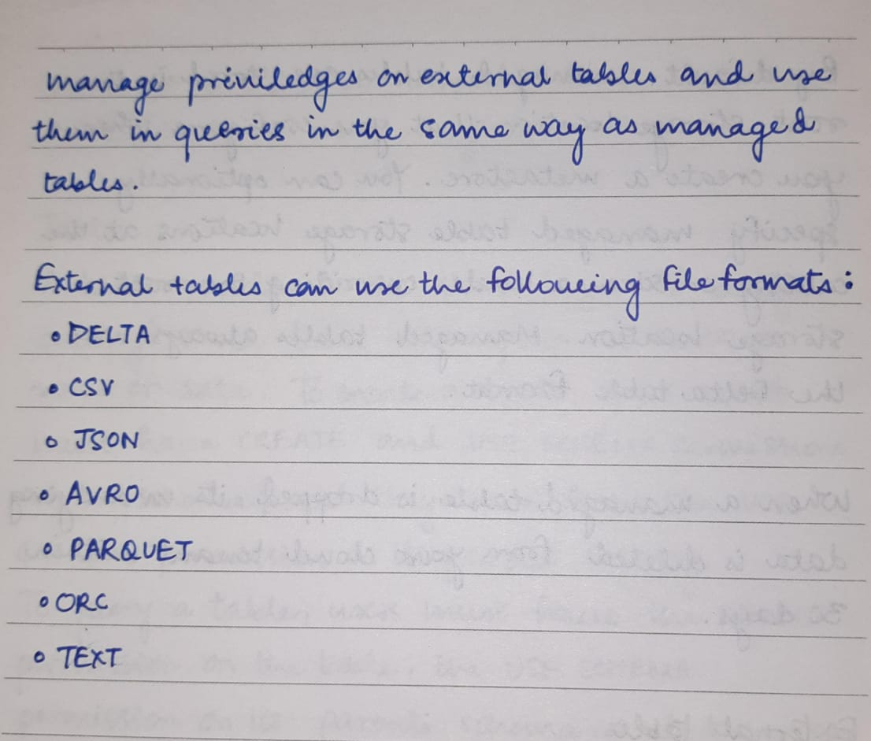

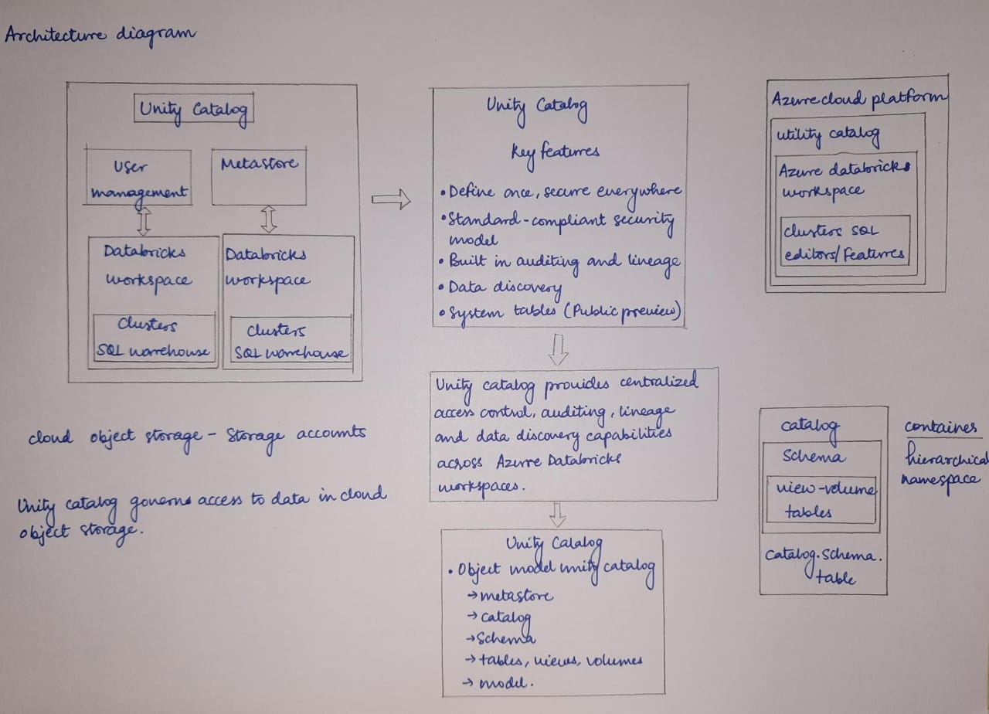

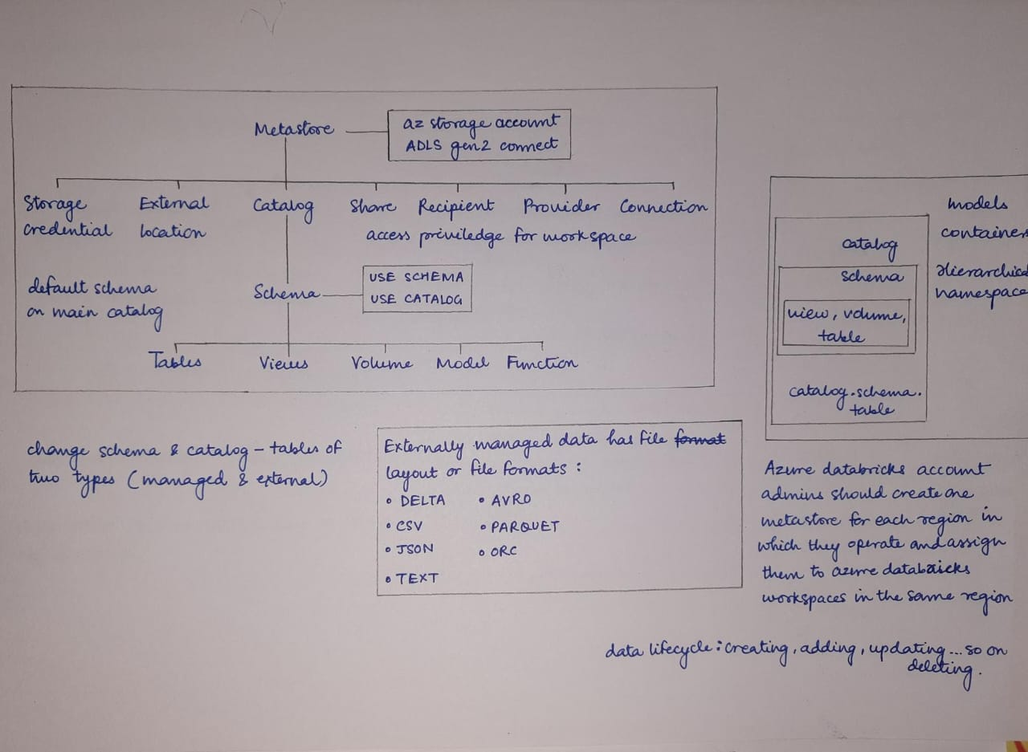

**HANDS ON:**

**SCHEDULE JOB:**

1. Open Microsoft Azure.
2. Create an Azure Databricks Workspace.
3. Launch workspace.
4. Create a cluster.
5. Create a new notebook.
6. Write the code.
7. Schedule the job from Schedule button in top right corner.

